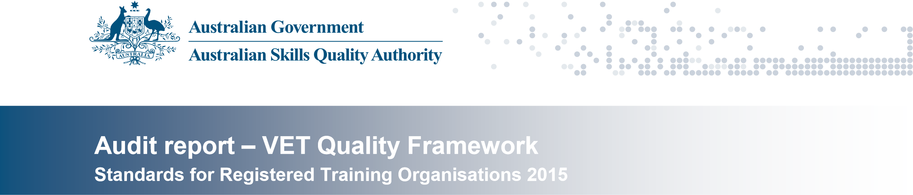
ORGANISATION DETAILS
Organisation’s legal name: | Yorke Institute Pty Ltd
Trading name/s: | Yorke Institute
RTO number: | 22040
CRICOS number: | 02893G
AUDIT TEAM
Lead auditor: | David Scott
Auditor/s: | nil
Technical advisor/s: | nil
AUDIT DETAILS
Application number/s: | nil
Audit number/s: | 1006022
Audit reason 1: | Compliance - monitoring
Audit reason 2: | n/a
Audit reason 3: | n/a
Activity type: | Site visit
Address of site/s visited: | 13 Elizabeth Street RICHMOND VIC 3121
Date/s of audit: | 5 & 6 August 2015
Organisation’s contact for audit: | Ms Kamini Jenarthan Chief Executive Officer kamini@yorkeinstitute.com (03) 8415 0366
Clauses audited: | 1.1, 1.2, 1.3, 1.4, 1.5, 1.6, 1.8, 1.13, 1.14, 1.15, 1.16, 1.26, 1.27,  2.1, 2.2, 3.4, 4.1, 5.2, 6.1, 6.2, 6.3, 6.4, 6.5, 7.3 & 8.1
BACKGROUND
Yorke Institute Pty Ltd trading as Yorke Institute has been operating for approximately eight years. It first registered with the VRQA in 2007 and transferred to ASQA in 2011. The current CEO has been there since 2007. The RTO is privately owned and operated and is a CRICOS provider.
RTO Management structure
The RTO has a Chief Executive Officer/owner and a part-time Compliance Manager that deal with all operations of the RTO.
Other strategic & operational groups that assist the RTO
The RTO also utilises Industry associations to assist them with developing and validating training and assessment.
General description of RTO location & facilities
The RTO has offices/training facilities located at 13 Elizabeth Street RICHMOND VIC 3121.
The RTO has a long term lease for facilities for the delivery of training and the conduct of assessment for the HLT50512 Diploma of Dental Technology in Coburg.
General description of training modes used by the RTO The RTO provides training using:
- classroom based delivery
- mixed/blended learning modes.
At this stage, the RTO does not deliver any courses/qualifications interstate or overseas.
RTO’s scope of registration
The RTO’s scope of registration is limited to Health and Business Services. There are nine qualifications on the RTO’s scope of registration; it does not deliver any stand-alone units of competency or skill sets as described on the Training Government website.
RTO current enrolment/s details
There are currently eleven students enrolled in HLT50512 Diploma of Dental Technology, three students in BSB50207 Diploma of Business and three students in the BSB60407 Advanced Diploma of Management.
RTO fee or funding information
The RTO offers its training and services as fee for service provider.

Total number of current enrolments in RTO as at audit date:
• 17

AUDIT SAMPLE
Code Training products Mode/s of delivery / Current enrolments
assessment* (If not yet on scope, record
N/A)
BSB50207 Diploma of Business Face to face 3
BSB50215 Diploma of Business Face to face 0
BSB60407 Advanced Diploma of Management Face to face 3
HLT50512 Diploma of Dental Technology Face to face 11
*Apprenticeship, Traineeship, Face to face, Distance, Online, Workplace, Mixed, Other (specify)

INTERVIEWEES
Name | Position | Training products
Ms Kamini Jenarthan | Chief Executive Officer | nil
Mrs Jennifer Garrard | Compliance Manager | nil

ORIGINAL FINDING AT TIME OF AUDIT
Audit finding as at 6 August 2015: Critical non-compliance
- The level of non-compliance considers the potential for an adverse impact on the quality of training and assessment outcomes for students.
- If non-compliance has been identified, this audit report describes evidence of the noncompliance.
- Refer to notification of non-compliance for information on providing further evidence of compliance.

AUDIT FINDING FOLLOWING ANALYSIS OF RECTIFICATION EVIDENCE
Audit finding following analysis of additional evidence provided on 30 September 2015: Compliant
AUDIT FINDING BY STANDARD
Standard | Original finding | Finding following rectification
Standard 1 | Not compliant | Compliant
Standard 2 | Not compliant | Compliant
Standard 3 | Compliant | n/a
Standard 4 | Not compliant | Compliant
Standard 5 | Not compliant | Compliant
Standard 6 | Not compliant | Compliant
Standard 7 | Compliant | n/a
Standard 8 | Compliant | n/a
ABOUT THIS REPORT
This report details findings against the Standards for Registered Training Organisations 2015.
The evidence guidance included against each clause is designed to guide the auditor and RTO on the requirements of the clause. The evidence guidance is not designed to limit the audit findings and there may be other factors an auditor takes into consideration when determining whether compliance has been demonstrated.
Where evidence of non-compliance is identified, the ‘Reasons for finding of non-compliance’ section of the report will document the issues that were considered in the formulation of a finding of noncompliance.

